SMART EMOTION-BASED AROMA DIFFUSER SYSTEM

Senthilnadhan S, M. Yoga,
Assistant professor, Assistant Professor,
Department of Computer Science and Engineering, Department of Artificial Intelligence and Machine Learning,
Velalar College of Engineering and Technology, Thindal, |  | Kongu Engineering College, Perundurai.
Erode. |  | Kongu Engineering College, Perundurai.
s.senthilnathan4@gmail.com |  | yogamecse@gmail.com
Gomathi selvi G, | Atchaya S D | Kavibharathi K
Department of Computer Science and Engineering. | Department of Computer Science and Engineering. | Department of Computer Science and Engineering.
Velalar College of Engineering and Technology, Thindal, Erode, India. | Velalar College of Engineering and Technology, Thindal, Erode, India. | Velalar College of Engineering and Technology,Thindal,Erode, India.
gomathikkn10a@gmail.com | atchayasrinivasan25@gmail.com | kavibharathi180k@gmail.com

Abstract
The Smart Emotion-Based Aroma Diffuser System is designed to improve a person’s emotional condition such as stress, anxiety, happiness, sadness, or surprise by using aroma therapy. The proposed system aims to create a smart automation system for mental well-being using natural aroma therapy methods. In our project, different types of aromas are used to calm human emotions and create a relaxed feeling. Facial expressions are detected using AI, which uses deep learning techniques. Based on the detected emotions, a specific aroma is automatically released through the diffuser. This helps in reducing stress and improving the mood of the user without any manual devices. Our project provides an innovative solution that can be used in homes, offices, and therapy centers to help emotional stability and relaxation. This demonstrates how technology can be combined with natural therapy to enhance mental wellness. Existing aroma diffusers were manual and automatic aroma diffusers with a timer and with one natural aroma dispenser, but we have integrated a Smart Aroma Diffuser with four different aromas used in aroma therapy, which are Rosemary, Eucalyptus, etc., so these were scientifically proven by research. In the future our project aims to create a Smart desktop device by adding the features of calm music, a night lamp for studies to support workers and students, and also we will include an IoT system to control and monitor the aroma slots in our Mobile App. Thus our project helps in a natural method with the support of AI technology to help human mental well-being.

Keywords: Emotion Detection, Convolutional Neural Network (CNN), TensorFlow (Keras), OpenCV, Arduino UNO, Smart Aroma Diffuser, Mist Maker, Deep Learning, Facial Expression Recognition, Embedded Systems, Real-Time Processing, Smart Wellness System, Human Computer Interaction, Automated Aroma Therapy.

I. INTRODUCTION
In today’s situation, stress has become something that almost everyone experiences at some point. Whether it is because of studies, work pressure, or daily responsibilities, people often find it difficult to stay mentally relaxed. Over time, this can affect both their health and their ability to focus on tasks. Because of this, taking care of emotional wellbeing is now considered important [1].

Aromatherapy is one of the methods people try when they want to feel less stressed. It mainly involves using natural oils rather than medicines. These oils are said to influence mood to some extent. For instance, lavender or citrus oils are commonly chosen, since people often say they feel slightly calmer after using them [2][3].
Emotions also affect how a person behaves in day to-day situations. The same person may react differently depending on their mood. There are several ways to understand emotions. and there are some that analyze biological cues [4].

However, in practical applications, facial expressions have been used for the simple reason that they are easily observable and give instant feedback on a person’s emotions [5].

With advances in artificial intelligence, it has become possible to create systems that can analyze the emotions based on facial images. Such devices analyze facial images not directly, but using various patterns and features analyzed with machine learning models. It is worth mentioning that often the technology of deep learning is used in this kind of system. Because of this, today such devices are gradually implemented in medicine and other fields, such as education, to help improve communication [6][7].

It should be noted that the sense of smell is strongly correlated with emotions. That is, the area of the brain responsible for the processing of smell sensations is also connected with memory and emotions. That is why particular scents affect a person's mood in a moment [8].

Although there are aroma diffusers, today their operation does not depend on the emotion of the person. Most of the existing systems can only be manually controlled or run according to the set schedule regardless of the user's emotional state
[9].

There were some studies exploring the implementation of technologies, such as EEG signals, to detect emotion, but it does not seem to be practical in real-life conditions due to the need of using additional equipment [10].

The emergence of IoT technology helped make such devices more adaptive to the user and enable monitoring and control in real time [11].

However, systems that combine the detection of emotions and aromatherapy in one device are quite limited [12].

The aim of the research is to combine these technologies in order to develop a new product based on these concepts.

II.RELATED WORKS:
Many researchers have made their contribution in areas related to emotion detection and aromatherapy systems through the use of technology such as artificial intelligence, machine learning, and Internet of Things. Various techniques have been investigated in order to analyze human emotions and increase user comfort. There are studies that concentrate on aroma diffusers' systems.
One of them, Pan et al. [1], developed an intelligent aromatherapy system based on the usage of Arduino along with several atomizers to release essential oils. This work demonstrated that aromatherapy can be integrated into smart devices; however, the system was not capable of detecting the emotional state of the user in real-time. Emotional Recognition by means of analyzing humans' faces is another widely researched field nowadays.
In particular, Kaur and Kumar [2], analyzed various approaches to recognize emotions from the face by means of AI. Similar topics have been covered by Dalvi et al. [3], who described how machine and deep learning can help to detect users' emotions by analyzing facial expressions. However, most of them concentrated on recognition accuracy rather than real-time implementation.
Another study by Joshi and Kanoongo [4] used AImethods to identify emotions from speech, text, and facial expressions. Even though the system could detect emotions properly, it did not provide any response mechanism for improving the user’s emotional state.
Jafari et al. [5] worked with EEG-based emotion detection methods using deep learning. The results were effective, but the setup required complex hardware, making it difficult for normal everyday usage.
Zhang et al. [6] observed emotion recognition methods and mentioned that combining different data sources can improve performance.
Zhuang et al. [7] developed a fragrance diffuser controlled through EEG signals for regulating mental states. However, the system was expensive and not very convenient for common users.
Some researchers mainly discussed scent-related technologies. Bual [8] explained the use of smart diffuser systems and scent interfaces in technologybased environments.
Bercik et al. [9] studied the influence of aromatherapy on human emotions and behaviour in different industries. These studies proved the usefulness of aroma-based methods, but intelligent emotion detection was not included.
Other works focused more on CNN and image classification models. Lei et al. [10] showed that CNN models perform well in image classification tasks.
Kaur et al. [11] also used CNN techniques for face mask detection systems. Even though these studies proved that CNN models are effective, they were not directly connected with emotional analysis.
There were also studies explaining the health benefits of aromatherapy. Reis and Jones [12] highlighted the supportiveness of essential oils in medical treatment.
Likewise, Agarwal et al. [13] reported that citrus oils are used to relax and improve mood. SanchezVidana et al.
Wood and Carini [19] highlighted the effectiveness of relaxation methods such as aromatherapy in managing stress.
However, the aroma reaction was not considered in the proposed algorithm. The major objective of this project is to integrate both concepts in a unified manner. The proposed system will detect the user's emotions through the facial expression and release suitable aromas.
The integration of two technologies makes the proposed concept more interactive, feasible, and convenient for the user. The proposed system aims to integrate emotion detection and aroma diffusion systems into a unified system. The camera will capture the facial expression of the user, which will be analyzed through machine learning techniques.
Once the emotion is detected, the diffuser will automatically release suitable aroma according to the detected emotion. Various types of essential oils will be attached with different emotional conditions to facilitate the relaxation of the user.
One other significant aspect of the proposed system is its automation feature. The system will automatically control the diffuser according to the detected emotion, thereby eliminating the need for manual intervention.
Aroma bottles are used for storing different essential oils like lavender, peppermint, citrus, etc. An aroma bottle is associated with a particular emotion. When an emotion is detected, it triggers a corresponding aroma cartridge for personalized aroma generation. This helps in selecting an aroma depending on the mood, and an enhanced user experience is provided.

III. SYSTEM BLOCK DIAGRAM

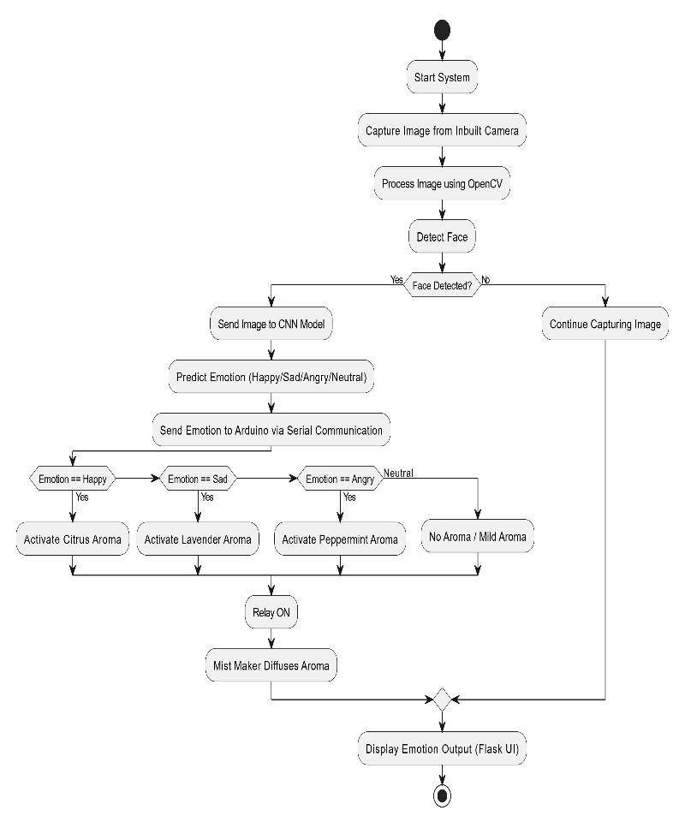
IV. METHODOLOGY
A) Hardware Module
Arduino UNO:
The Arduino UNO board is used to manage all the operations of this system. It is built around the ATmega328P microcontroller. The board gets the emotion data from the software section and then carries out the required task based on that information. Different components, including the relay module, are connected through the digital pins available on the board. . The Arduino UNO is widely preferred because it is less expensive and simple to use. It can also be connected easily with both hardware and software modules. In this system, the board helps convert the detected emotion into real-time actions.

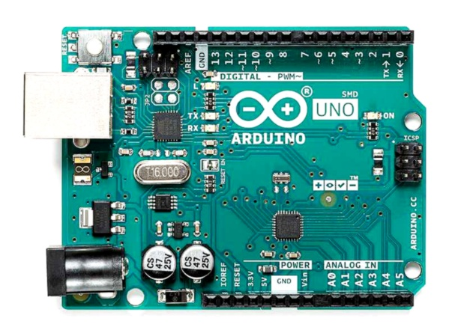
Figure 1 : Arduino UNO

Relay Module:
In this system, the relay module is mainly used for controlling devices by switching them ON and OFF. It also helps the Arduino board connect safely with components like the mist maker. Since the Arduino works only with low voltage and current, it cannot directly operate those devices. So, the relay module is connected between the Arduino and the output device. When a signal is sent from the Arduino, the relay receives it and performs the required switching operation.

Aroma Bottles:
Aroma bottles are used for storing different essential oils like lavender, peppermint, citrus, etc. An aroma bottle is associated with a particular emotion. When an emotion is detected, it triggers a corresponding aroma cartridge for personalized aroma generation. This helps in selecting an aroma depending on the mood, and an enhanced user experience is provided.

Power Supply Unit:
Power Supply Unit: The power supply unit serves as the energy source in which constant current flows to energize all the components of the system. It converts the alternating current from mains to direct current required by the components including Arduino, Relay Module, and Mist Maker.

Inbuilt Camera (Laptop Camera):
Inbuilt Camera (Laptop Camera): The inbuilt camera will capture images of the facial expressions while using the device. The captured images are processed by the software module to recognize different emotions from the images. The use of laptop camera will make it possible to reduce cost of the system. The images captured are processed using the OpenCV library.

B) Software Module

TensorFlow (Keras):
TensorFlow works to train the CNN model in recognition of emotions. Keras helps to create the model which is made up of various layers. It recognizes different types of emotions based on the analysis of facial expressions.
OpenCV:
OpenCV is the software used for the real-time processing of images. Images are captured by OpenCV and analyzed to detect the presence of faces after which preprocessing of the images takes place.
Flask:
Flask creates the web-based user interface for the system. It displays the live video feed and shows the detected emotion to the user in real time.
Arduino IDE:
Arduino IDE helps in writing and uploading programs to the Arduino UNO board.
Communication between Python and the Arduino board takes place through this platform, allowing the relay module to respond according to the detected emotion.

Parameter | Threshold  /Condition | Unit | Action  Triggered
Emotion | Happy | Label | Citrus  aroma ON  (Mild  Diffusion)
Emotion | Sad | Label | Lavender  aroma ON  (Calming  Effect)
Emotion | Angry | Label | Peppermint  aroma ON  (Stress  Relief)
Emotion | Neutral | Label | No aroma /  Low  Diffusion
Confidence (%) | < 50 | % | No action  (Ignore detection)
Confidence (%) | 50 – 75 | % | Moderate aroma activation
Confidence (%) | > 75 | % | Strong aroma activation

Table 1: Emotion-Based Aroma Classification Table

C. Emotion Classification and Aroma Control Logic
A deep learning-based approach is used to classify human emotions based on facial expressions captured through the inbuilt camera. The Convolutional Neural Network (CNN) model processes the facial features and predicts the emotional state of the user in real time.
When the detected emotion indicates a stable condition, the system only monitors and displays the emotion without activating any aroma.

Process Step | Response Time
Face Detection | ~0.5 sec
Emotion Prediction | ~1 sec
Arduino Activation | ~0.5 sec
Aroma Diffusion Start | ~1 sec

Table 2: System Response Time Analysis

The system architecture of the proposed system has been composed of the following major modules:
Emotion Detection Module:
This module detects the human emotions through facial expression created by using the CNN model implemented with TensorFlow(Keras) to detect and classify the emotions such as happy, sad ,angry and neutral.
Image Processing Module:
This model uses the OpenCV to enable the realtime detection of humans face and sending them to the CNN model to predict and classify the emotion.
Communication Module:
This module is used for communication between the computer and Arduino UNO through serial communication Control Module (Arduino UNO):
This module uses the relay module to trigger the suitable aroma that is detected and send the data through the Arduino
Aroma Diffusion Module:
This module is responsible for releasing fragrance. With the help of a relay, the mist maker is turned on or off depending on the detected emotion, creating a more personalized atmosphere.

Display Module:
This module displays the detected emotion using either a Flask-based web interface or an LCD display.

The camera is always watching the user's face to see how they are feeling. After taking the picture, it is processed before being sent to the CNN model to figure out what emotion it shows.Upon detection of the emotion, the relevant signal is then sent to the ArduinoUNO board.

In cases where the detected emotion shows signs of distress, the mist maker will be automatically triggered by the relay module to produce a suitable aroma. Simultaneously, the detected emotion is shown to the user via the web interface.
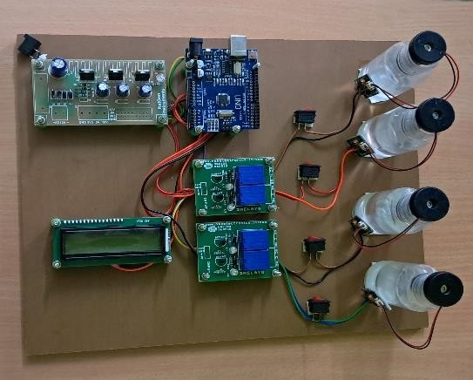
Figure 2: Hardware Prototype

V. RESULTS AND DISCUSSION
The Smart Emotion-Based Aroma Diffuser System was tested on people in different emotional states by using a camera. A CNN model could help the system figure out how people feel, like happy, sad, angry, or neutral.
It was observed that the system could accurately detect the emotions at an accuracy of approximately 90%. In addition, it was observed that the system accurately identified emotions even in varying light conditions and different facial postures. It takes about 1 second to detect the emotions.
After finding the right emotion, it was sent to the Arduino UNO microcontroller, which turned on the relay module. After 1 to 1.5 seconds, the aroma starts to diffuse.
For instance, when the emotion "anger" was found, the sandalwood scent was spread to help the person feel better. Similarly, when the emotion "sadness" was detected, the lavender aroma diffused to relieve the person from the stress.

- CONCLUSION
Smart Emotion-Based Aroma Diffuser System can be considered an innovative approach toward improving user experience by utilizing emotionaware automation techniques. In addition, the Smart Emotion-Based Aroma Diffuser System is implemented successfully by combining computer vision, deep learning algorithms, and embedded system technology. Moreover, the proposed system has the ability to provide aroma diffusions depending on human emotion and facial expressions in real-time. Therefore, this system has both accuracy and speed and it can be applied in many places including hospitals, offices, and homes.

- REFERENCES
- J. Pan, T. Xi, and R. Jiang, “Emotional effects of smart aromatherapeutic home devices,” in Proc.
Int. Conf. Applied Human Factors and Ergonomics, Cham, Switzerland: Springer
International Publishing, Jun. 2019, pp. 498–503.

- M. Kaur and M. Kumar, “Facial emotion recognition: A comprehensive review,” Expert Systems, vol. 41, no. 10, p. e13670, 2024.

- C. Dalvi, M. Rathod, S. Patil, S. Gite, and K. Kotecha, “A survey of AI-based facial emotion recognition: Features, ML & DL techniques, agewise datasets and future directions,” IEEE Access, vol. 9, pp. 165806–165840, 2021.

- M. L. Joshi and N. Kanoongo, “Depression detection using emotional artificial intelligence and machine learning: A closer review,” Materials Today: Proceedings, vol. 58, pp. 217–226, 2022.

- M. Jafari, A. Shoeibi, M. Khodatars, S. Bagherzadeh, A. Shalbaf, D. L. García, J. M. Gorriz, and U. R. Acharya, “Emotion recognition in EEG signals using deep learning methods: A review,” Computers in Biology and Medicine, vol.
165, p. 107450, 2023.

- J. Zhang, Z. Yin, P. Chen, and S. Nichele, “Emotion recognition using multi-modal data and machine learning techniques: A tutorial and review,” Information Fusion, vol. 59, pp. 103–126, 2020.

- A. Y. Zhuang, Y. C. Lin, S. L. Yu, and P. C. Kuo, “A brain-sensing fragrance diffuser for mental state regulation using electroencephalography,” in Proc. 2021 IEEE 2nd Int. Conf. Human-Machine Systems (ICHMS), Sep. 2021, pp. 1–6.

- M. Bual, “Scent interfaces definition: Diffuser devices interaction and control,” in Proc. Int. Conf. Applied Human Factors and Ergonomics, Cham, Switzerland: Springer International Publishing, Jul.
2020, pp. 103–109.

- J. Bercik, K. Neomaniova, J. Galova, A. Mravcova, E. Sendra, D. López-Lluch, D.
Giacalone, B. Borusiak, B. Pieránski, M. Naskręt, and V. Ilko, “The use of aromatization and smart solutions in selected economic sectors,” 2021.

- X. Lei, H. Pan, and X. Huang, “A dilated CNN model for image classification,” IEEE Access, vol.
7, pp. 124087–124095, 2019.

- G. Kaur, R. Sinha, P. K. Tiwari, S. K. Yadav, P. Pandey, R. Raj, A. Vashisth, and M. Rakhra, “Face mask recognition system using CNN model,” Neuroscience Informatics, vol. 2, no. 3, p. 100035, 2022.
- D. Reis and T. Jones, “Aromatherapy: Using essential oils as a supportive therapy,” Clinical Journal of Oncology Nursing, vol. 21, no. 1, pp.
16–20, 2017.

- P. Agarwal, Z. Sebghatollahi, M. Kamal, A. Dhyani, A. Shrivastava, K. K. Singh, M. Sinha, N. Mahato, A. K. Mishra, and K. H. Baek, “Citrus essential oils in aromatherapy: Therapeutic effects and mechanisms,” Antioxidants, vol. 11, no. 12, p.
2374, 2022.

